**Star Oddi Standard Operation Procedures**

**Setting up device and Tough Book**

**-Plugging in device**

Currently, the Star Oddi communication box that uses the DB9 and USB connection, is compatible with the Panasonic tough book. Prior to going out to the field, connect all components to the communication box to the tough book and testing to make sure the connection between the devices exists.

Start by turning connecting the DB9 cable to the communication box, to the back of the tough book. Since the tough book is essentially waterproof, the back flaps that protect it from water damaged need to be lifted.

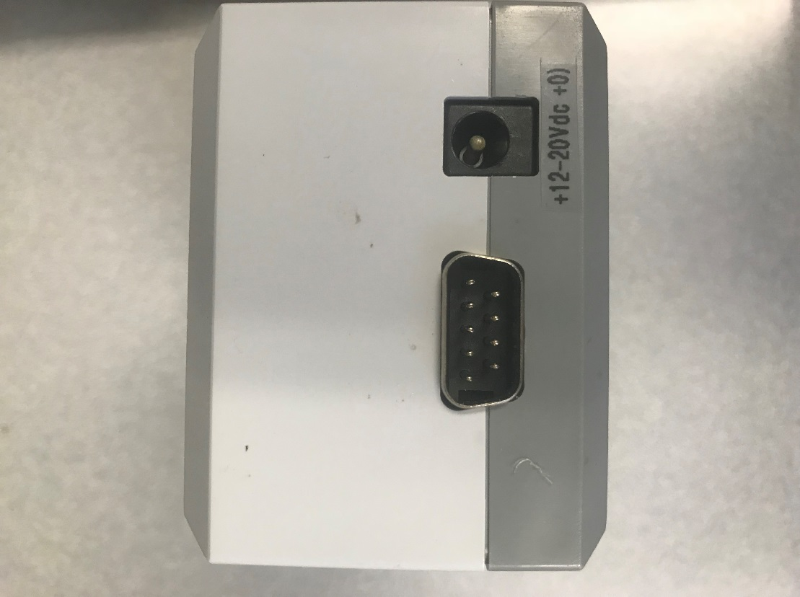

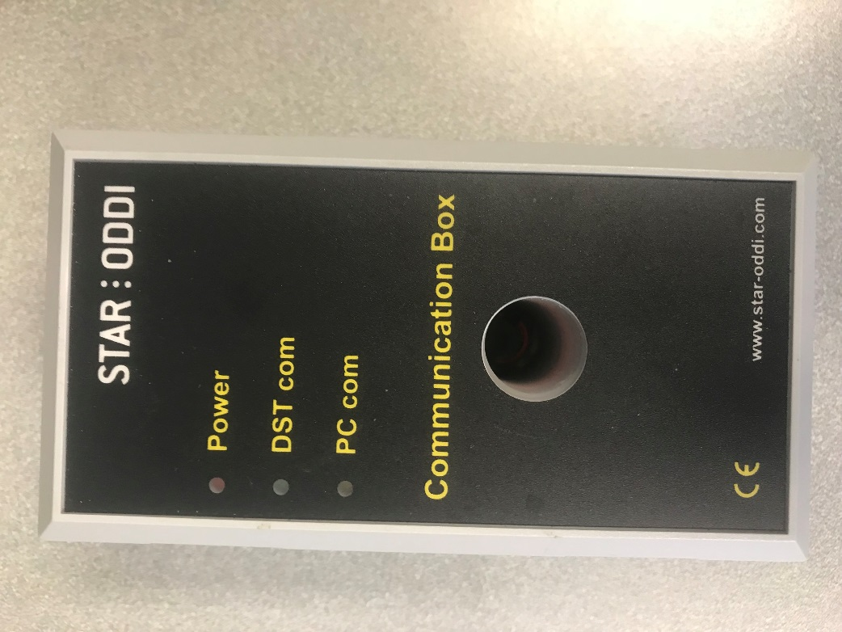

Figure 1.2- Back side of Star Oddi Communication box. (Left) DB9 male input. (Right) Power input.

Figure 1.1- Top of Back side of Star Oddi

Communication box. Currently turned off and not

plugged in.

**Connecting Power to the Star Oddi Communication box**

The Star Oddi Communication box is powered by a 9V battery. Test this connection by checking if the red “Power” light comes on when the battery is attached. Make sure to test this before going out into the field.

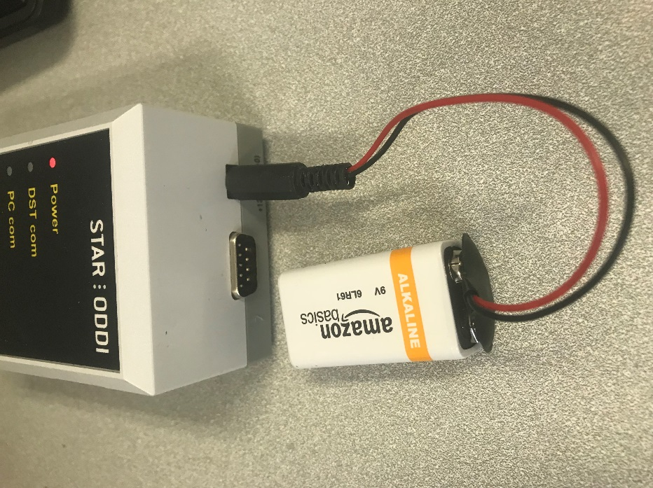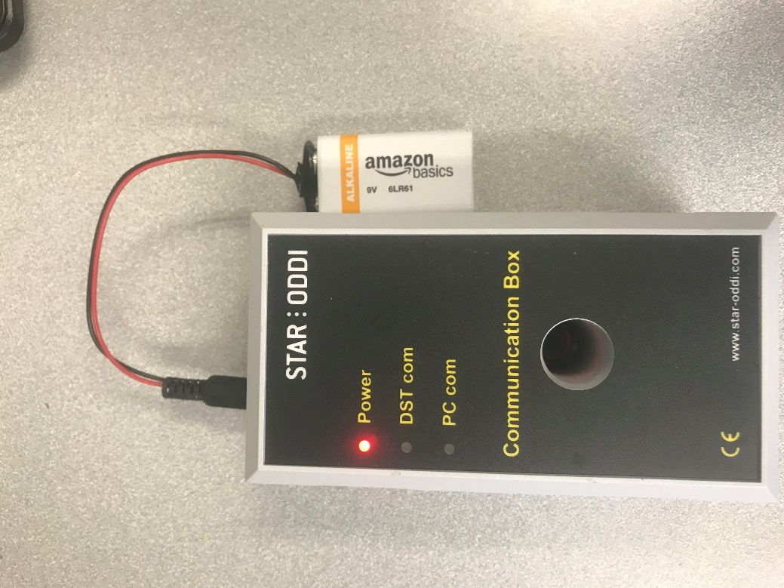

Figure 1.3- 9V battery connected to Figure 1.4- Back side of Star

Star Oddi Communication box, red Oddi Communication box, with

light should automatically turn on. 9V battery connected.

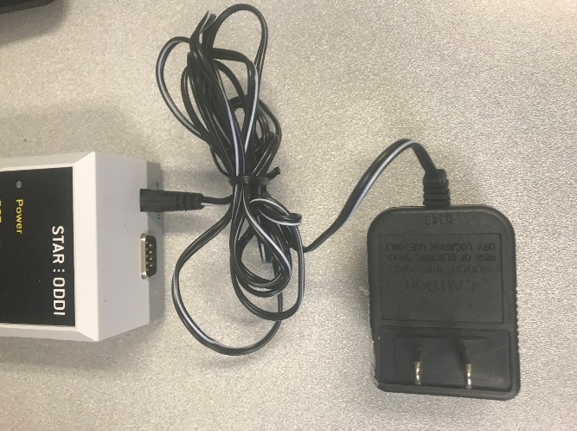

Figure 1.5- Power adapter for Star Oddi Communication box is available, but can only be used in an AC outlet, not available to be used in the field.

**Connecting 9DB cable to the Star Oddi Communication box**

The tough book accepts a DB9 cable connection from the Star Oddi Communication box. Attach the cable to the back of the communication box and to the back of the tough book.

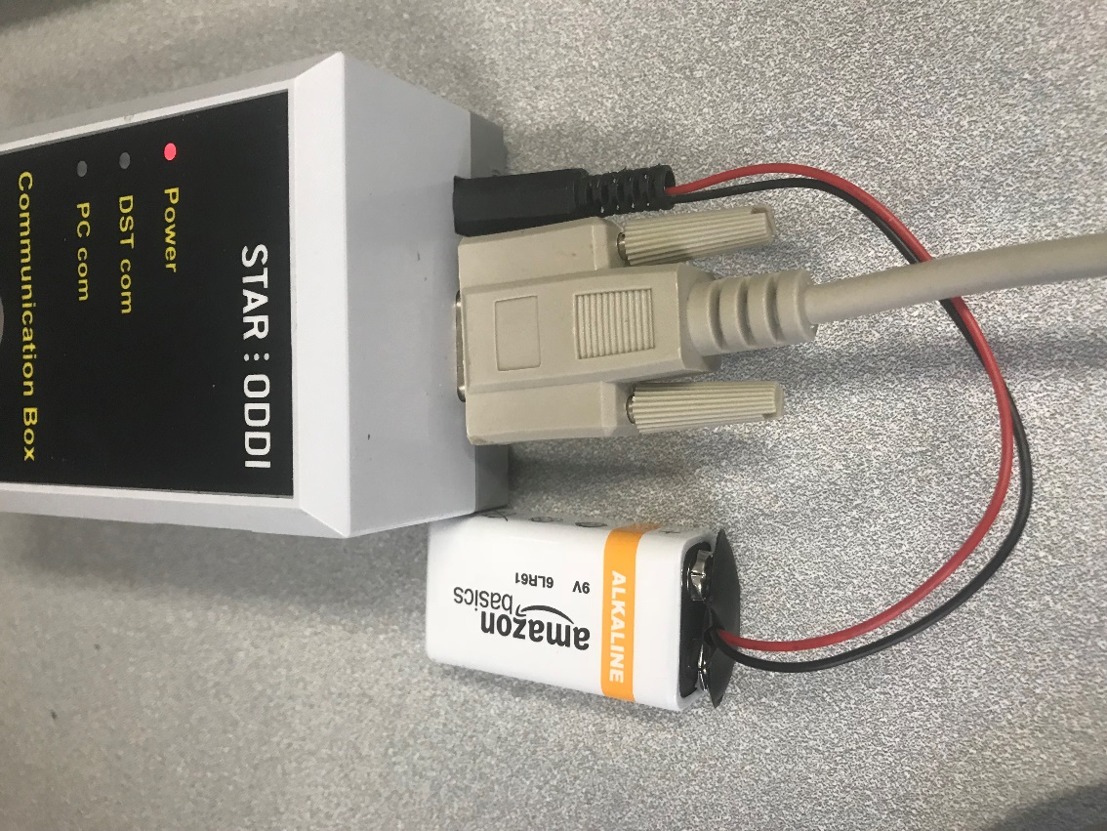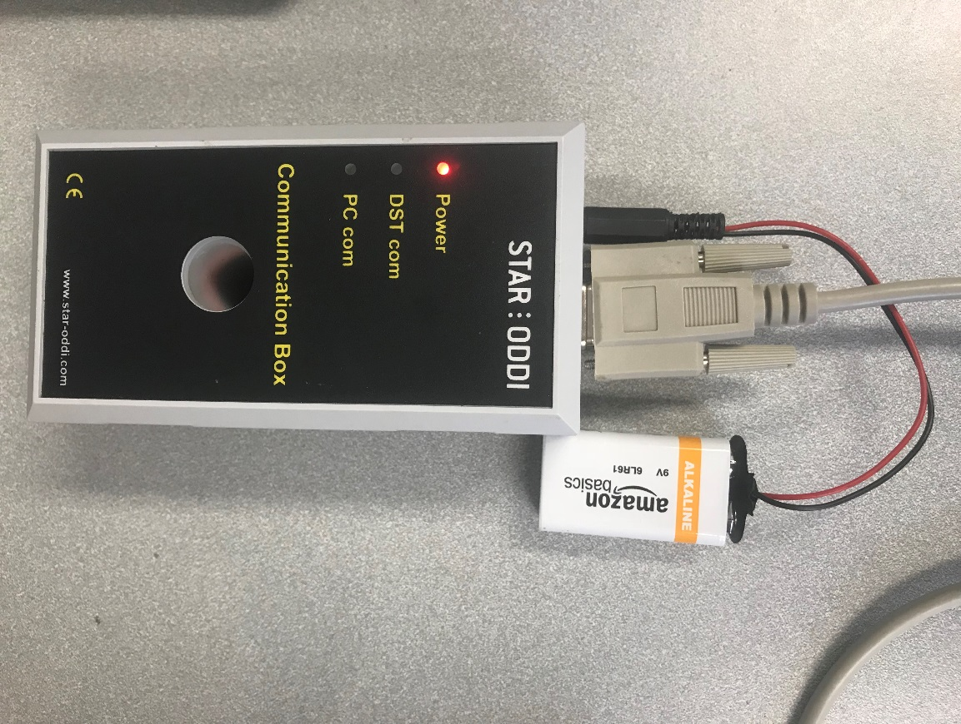

Figure 1.6- Top view of Star Oddi

Communication bow connected to the

9V battery and 9 DB cable. Figure 1.7- Top view of Star Oddi

Communication bow connected to the

9V battery and 9 DB cable.

If there are any issues, please refer to the SeaStar user manual, located in “Help”.

**SeaStar Software Instructions**

Click on the SeaStar application on the Desktop. The first screen will ask if you would like to “Run recorder connection wizard?” Click “Yes”.

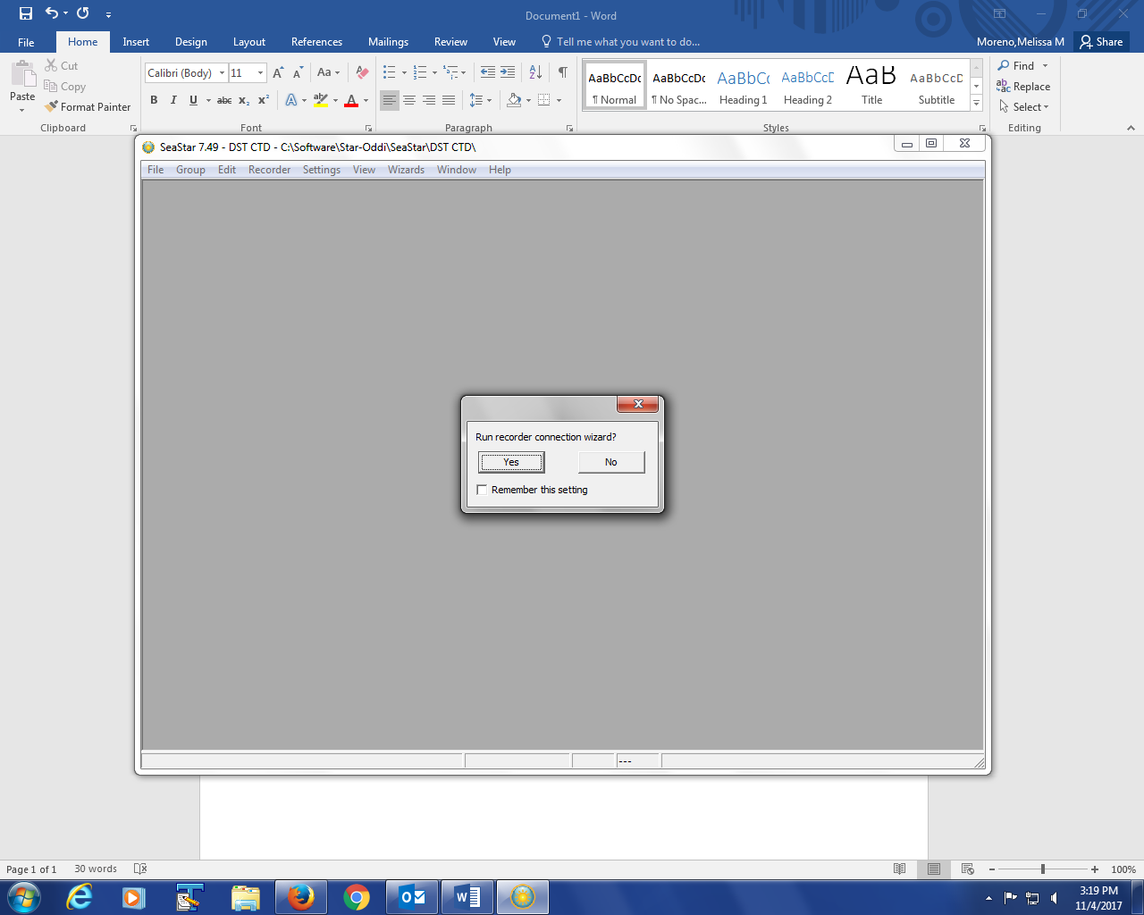

Once you are sure everything between the Star Oddi Communication Box, place the Star Oddi DST sensor in the designated slot in the communication box. A green “com” should light up with the DST model, and serial number of the sensor. Click “Next”.

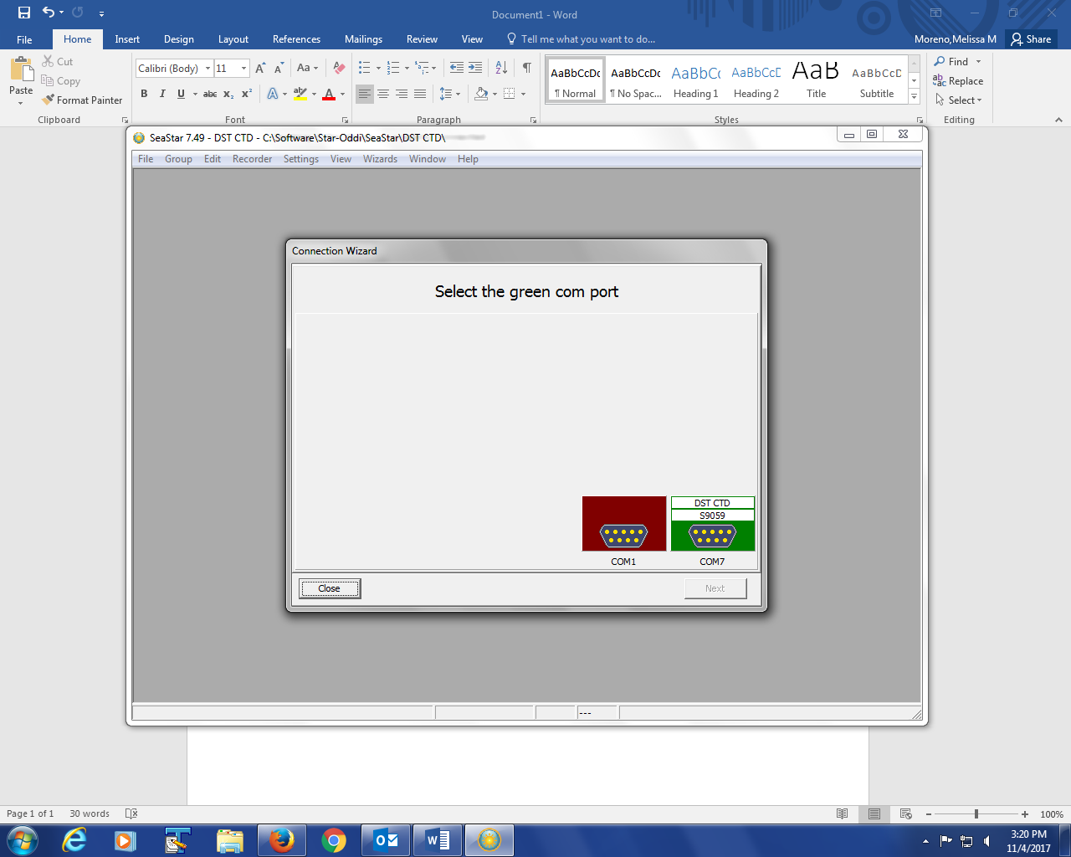

Once you click “Next”, the software it will ask you if you would like to “Retrieve recorder data”, click “Yes”.

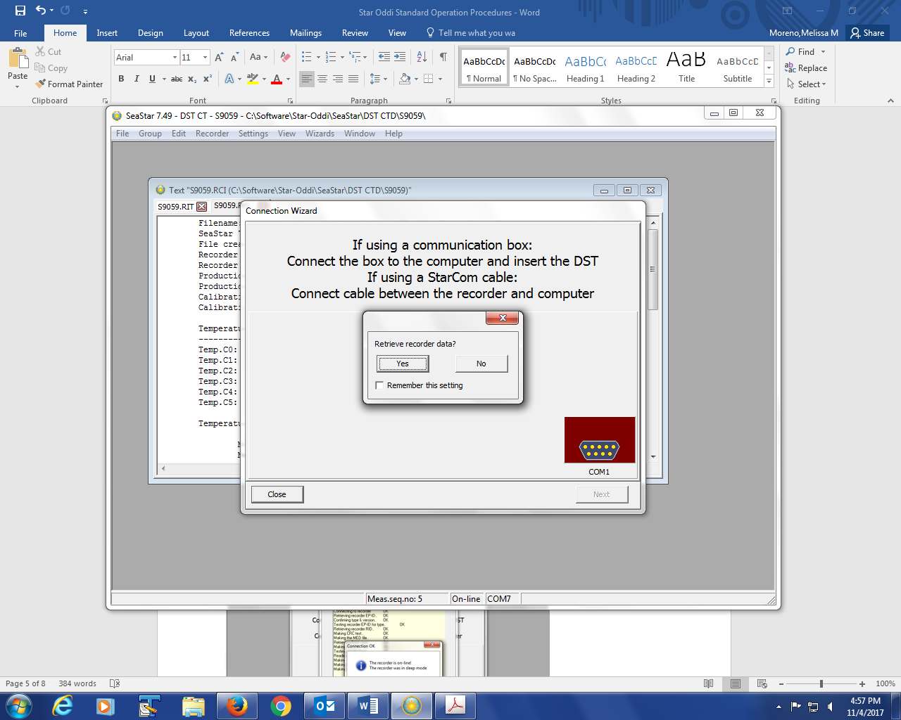

Once you click “Yes”, the software will start to download all the observations of the sensor. You should see that the “Number of measurements taken:__”. In this example, there are 81 observations, but normally you will have hundreds of observation per sensor in a monthly period.

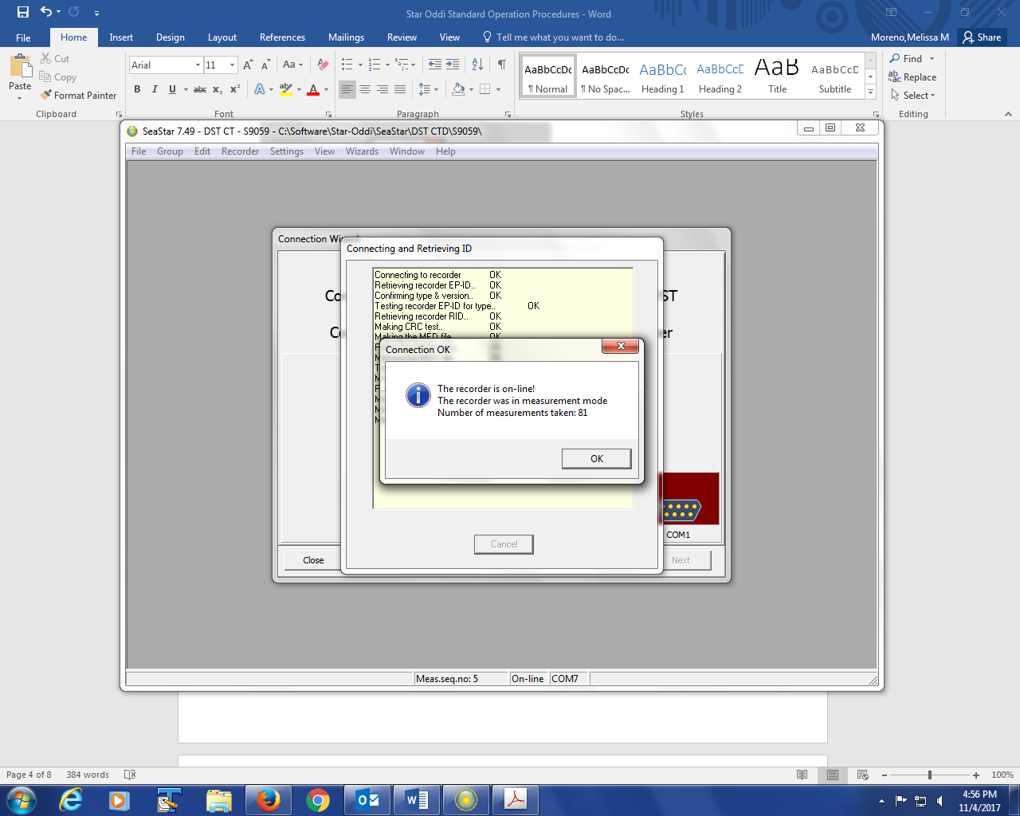

This screen, is the main sensor screen, which will allow you to change the status of the sensor, program and start recorder, restart recorder sampling interval, retrieve the data, and disconnect recorder. For our project, we need to make sure that our sensor remains in an active status. Under “Mode”, make sure there is a clock image. If this is your first time setting up the sensor, click on “Program and start recorder”, some examples will follow this page for this option. If you are not setting up the sensor for the first time, click on “Retrieve recorder data”.

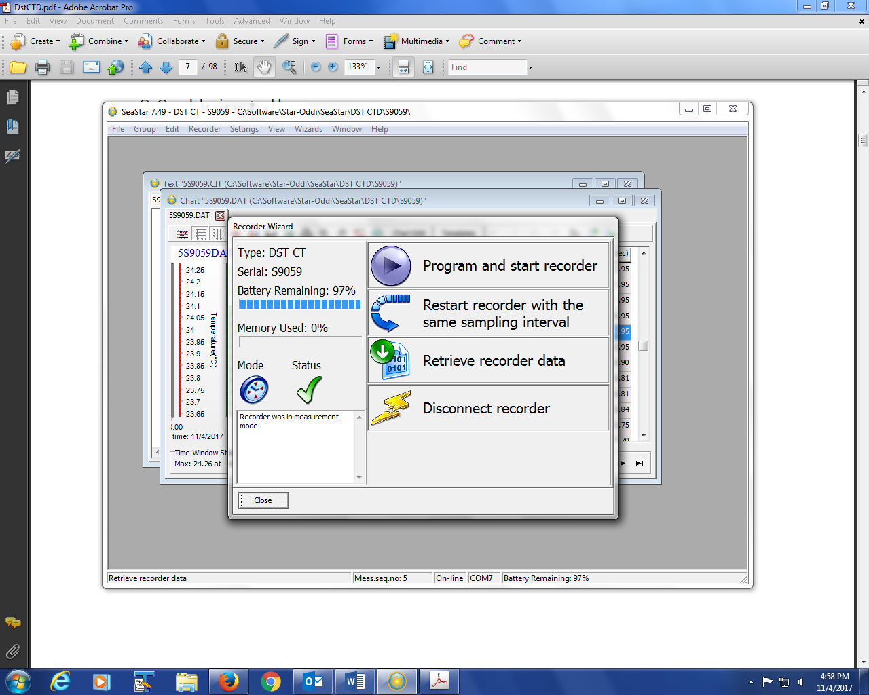

We’ve chosen “Retrieve recorder data”. You’ll see all the measurements of the sensor downloaded into the software. Choose to save these measurements by clicking on the floppy disk icon, to “save” the observations. Refer to the project manager on where to store these files on the tough book.

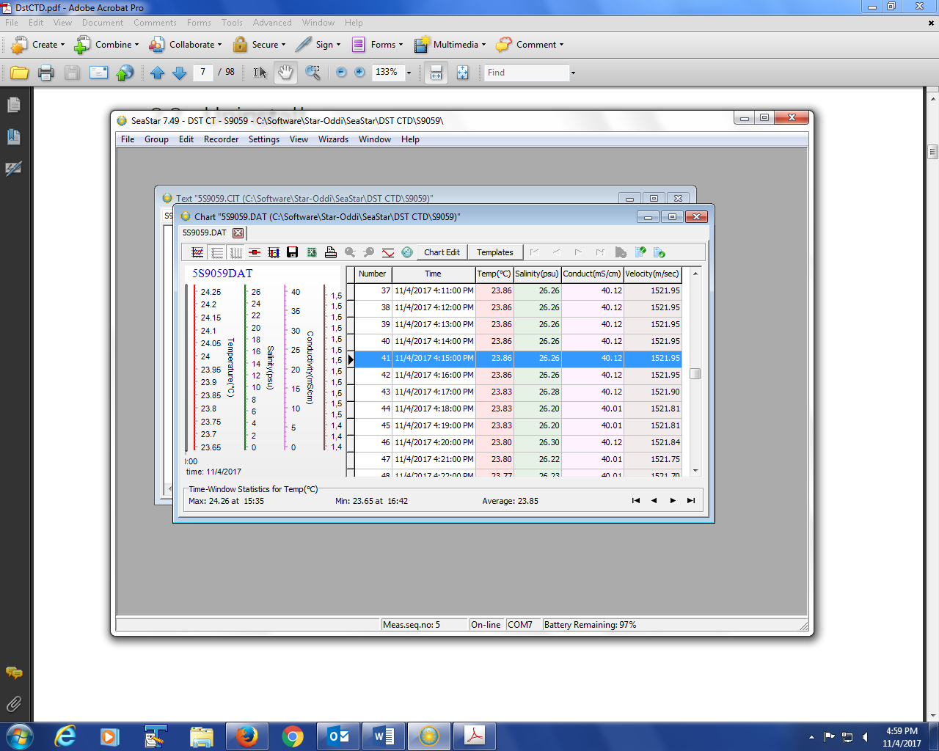

A screen such as this will appear once you click on the “Save As” icon. Choose the correct location and folder to save these observations. Make sure to also be aware of which sensor you have brought up in the software, since it will be important save the sensor observations to the same corresponding folder.

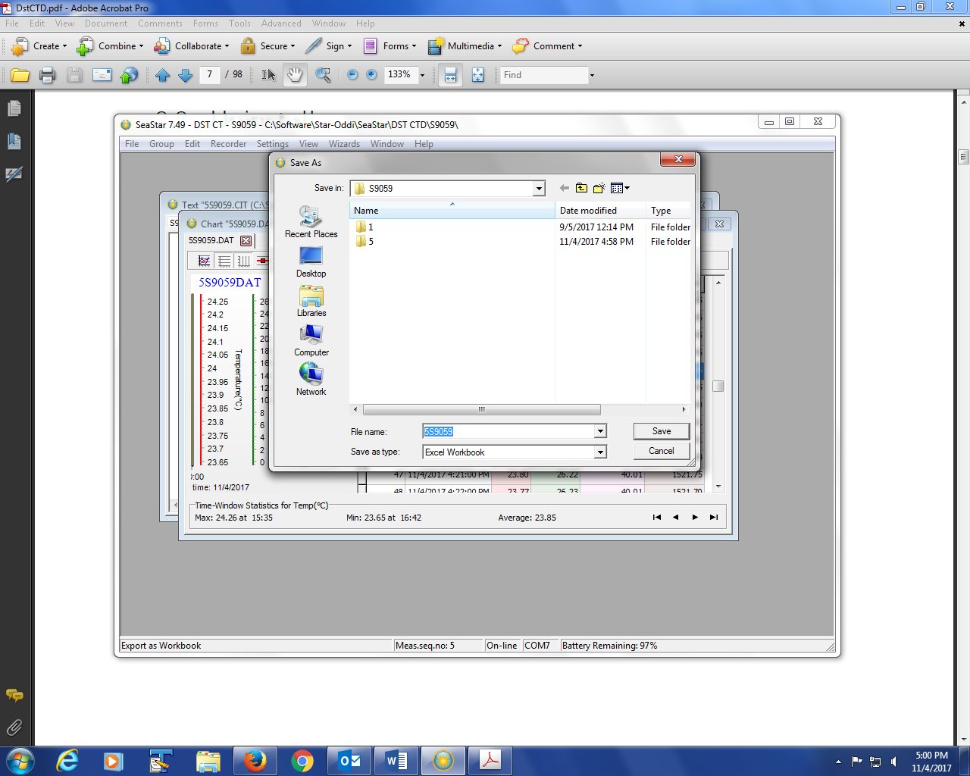

Once you’re done downloading and saving the measurements, you can choose to keep the sensor active, or put it to sleep. If your sensor is asleep, you will be a “Zz” under “Mode”. This means that your sensor will not record any measurements. Before placing the sensor back into the field, make sure that the sensor is not in this mode, unless it is being serviced.

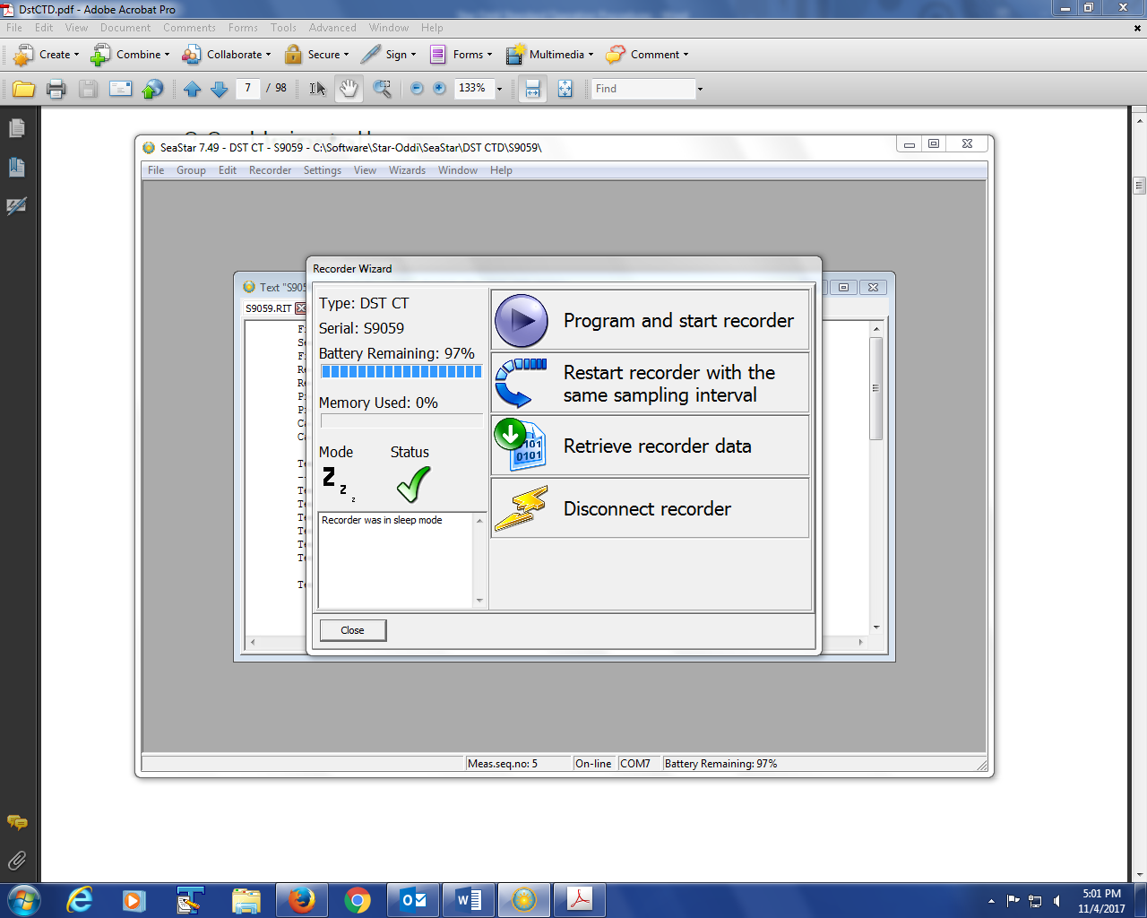

If you believe you set the recorder accidently in sleep mode, exit out of the software, and go back into the communication box settings, and the “Connection Ok”, screen will let you know if the recorder was online or offline. You can then proceed to start recording process.

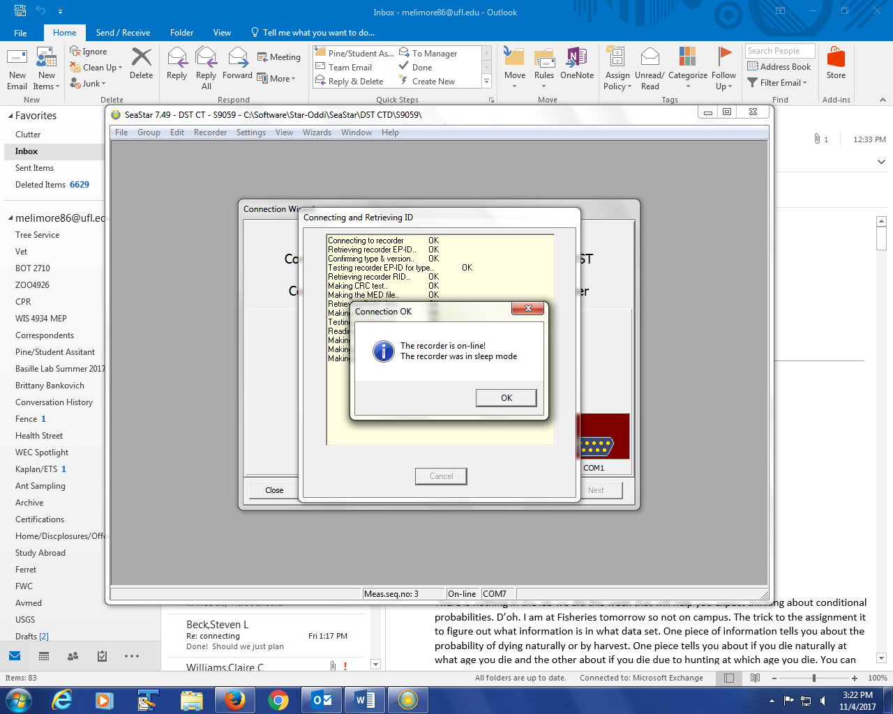

If your sensor is asleep, click on “Program and start recorder”, which will then prompt you to make an “Interval Definition” selection. Choose “Single recording interval (default)”.

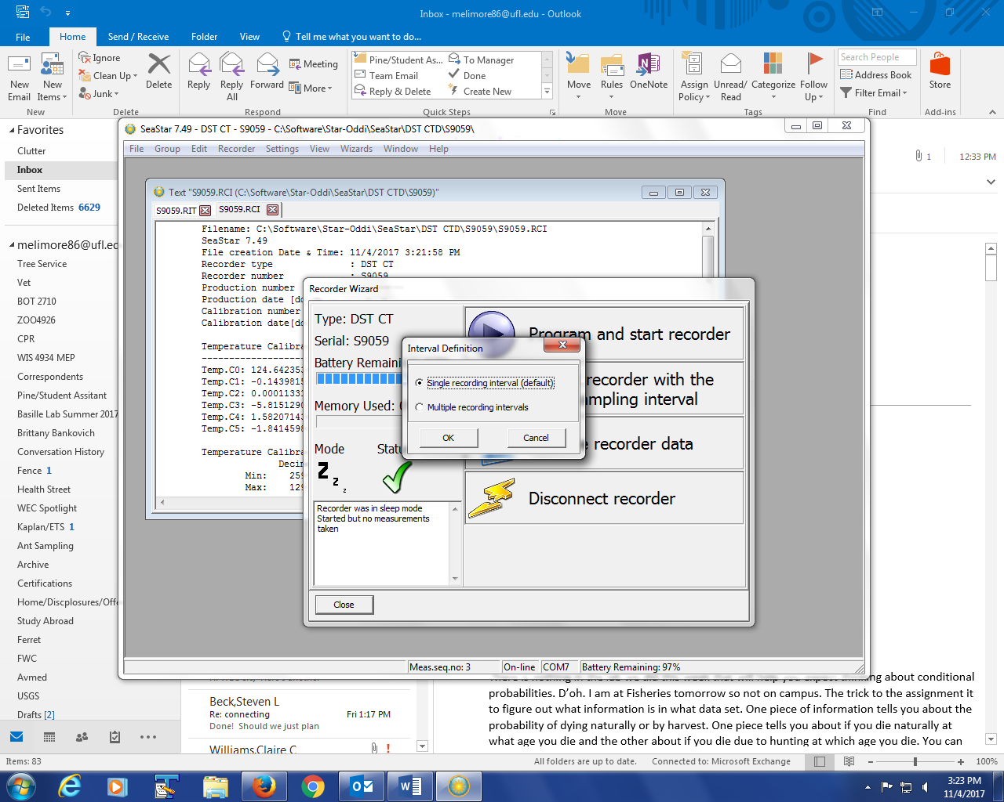

Under the “Set New Measurement Sequence”, select your start date, start time, and your interval time. Make sure to “Set Mode” as “Single mode”, so that every measurement is an individual observation on the spread sheet. Under “Battery & memory calculation {days}” , select “7 days”. Click “Ok”.

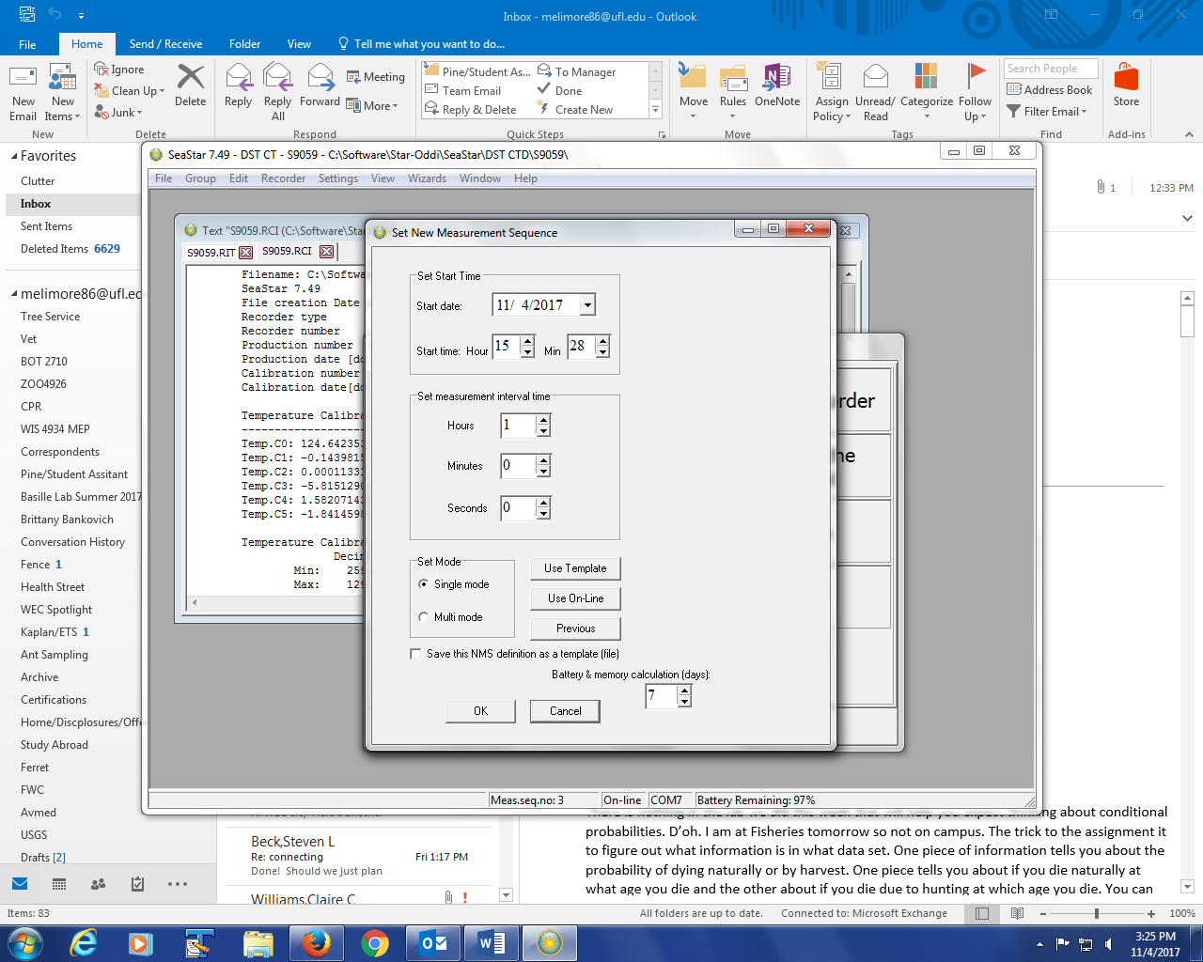

The next screen will summarize the selections you made in the previous screen. If any of the parameters you selected are not correct, press “Cancel”, and click on the “Program and start recorder”, and make the necessary changes.

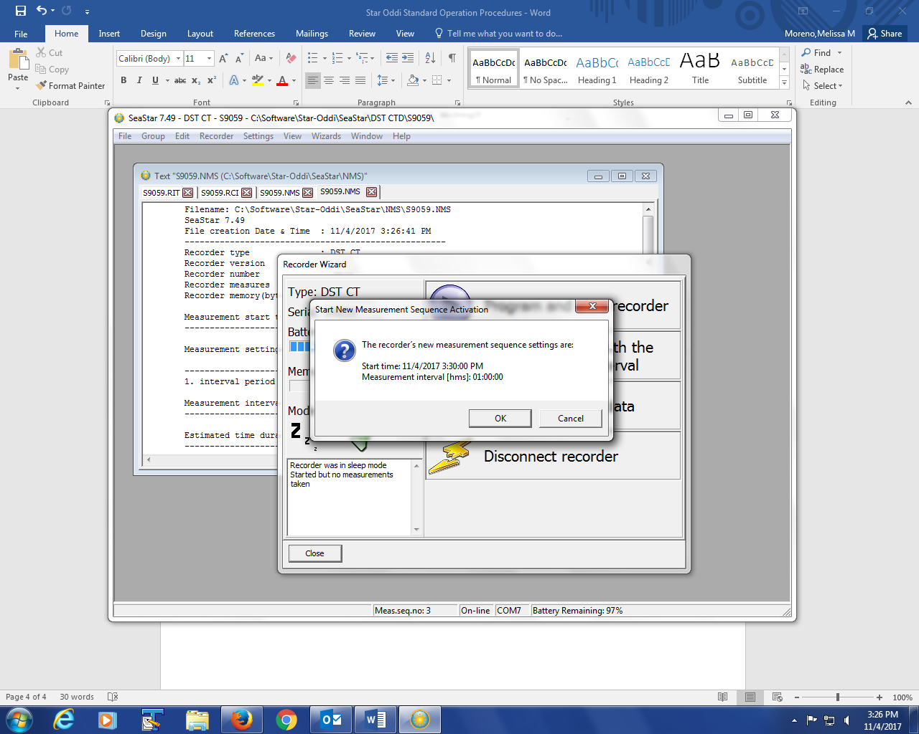

If everything was correct on the “Start New Measurement Activation” screen, click “Ok”.

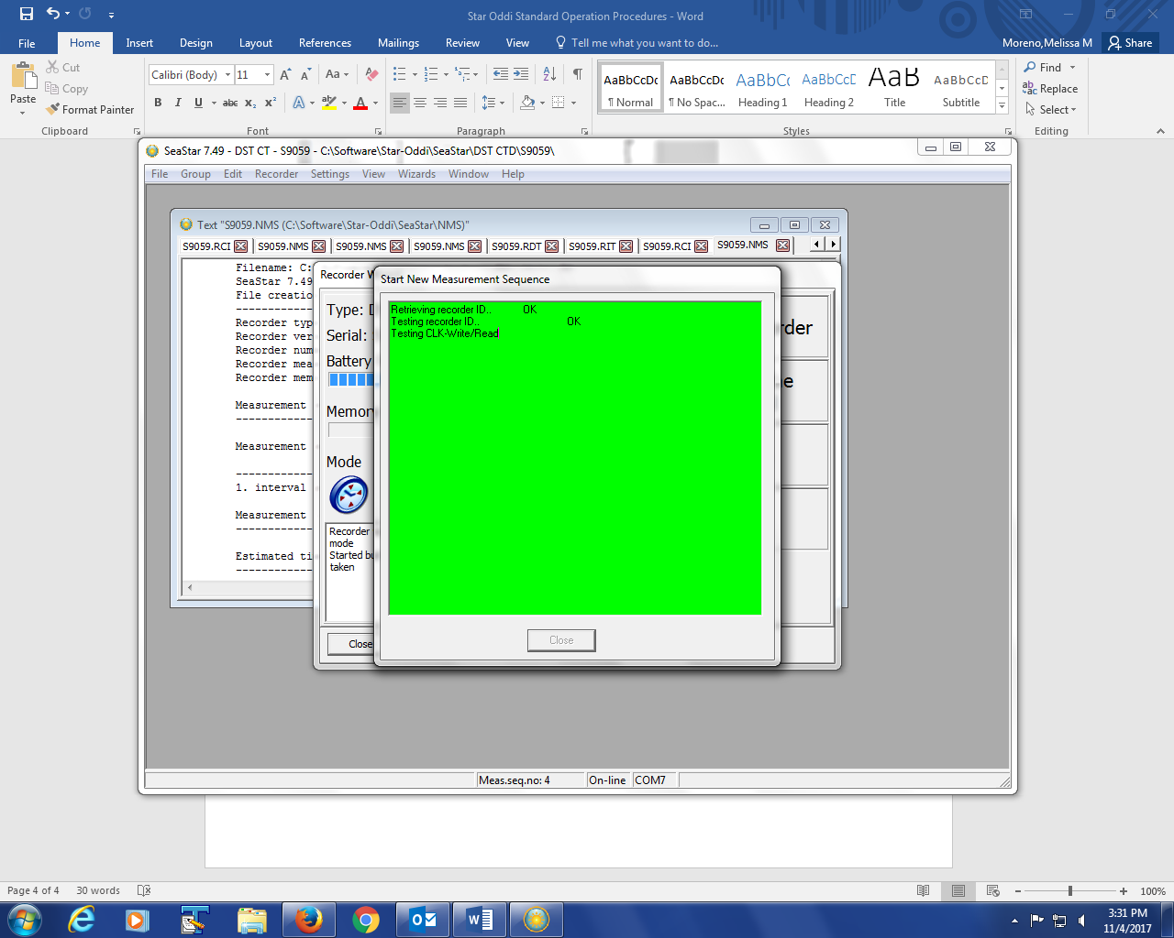

You should see a “Remove Recorder” window. Once you see this window, the recorder is active and set the with parameters you selected.

